#### **Data Visualization (INFO-I 590) | Final Project Paper | Fall 2024**

#### 

#### 

#### **Los Angeles Crime Dashboard: Analyzing and Visualizing Crime Patterns for Public Safety Insights**

**Team Members**

* Aaditya Dharne
* Mahimna Darji
* Hema Manasi Potnuru
* Shubh Mehta

**Table of Contents**

**Abstract**

Introduction

Motivation

Background

Existing Work and Critiques

● Koreatown Crime Data Project

Visualization Techniques

Effectiveness

● UK Crime Data Analysis Project

Visualization Techniques

Effectiveness

**Objectives**

**Process**

Data Collection and Analysis

Data Cleaning

Data Categorization

Challenges and Solutions

Candidate Visualization Methods

Why Certain Methods Worked While Others Did Not

**Results and Insights**

Geographic Patterns and Hotspots

Temporal Insights

Demographic Analysis

Crime Type Distribution

Visual Craftsmanship

**Discussion, Conclusion, and Future Work**

Discussion

Conclusion

Future Work

#### **Abstract**

The Los Angeles Crime Dashboard is designed to provide an intuitive platform on which to analyze and visualize the crime data of the city of Los Angeles. The project relies on publicly available data from the Los Angeles Police Department and focuses on crime trends, demographic disparities among victims, and geographic hotspots of criminal activity. Our approach involves cleaning and processing the data for accuracy, then creating an interactive dashboard using Streamlit for real-time analysis. A comprehensive visualization-heatmaps, bar charts, line graphs, and pie charts-provides full insight into the crime patterns across time, space, and victim demographics. The results herein will help inform policymakers, the police, and the general public in the best course of action and resource distribution for effective safety.

### **Introduction**

#### **Motivation**

Crime is a quintessential problem disturbing cities, and it involves not only community safety but lifestyle as well. LA, one of the largest, most cosmopolitan cities in the United States, has shown an average report of more than 300,000 crimes per year between 2015 and 2020, from violent crimes to property crimes to other illicit acts (Los Angeles Police Department Annual Crime Reports, 2020). Thus, it gives a suitable opportunity to study crime trends and their effects on police safety.

Existence of studies asserts that data-driven strategies are significantly helpful in preventing crimes. For instance, the research by Weisburd [3] emphasizes that hotspot policing-those that focus on cities with a high density of crimes-can bring down criminal activities by 20-50%, further supported, of course, by proper visualization of data [4]. Along similar lines, the goal of this project is to remedy the intermediary phase between raw data and the presentation of insights by means of interactive visuals for policymakers, law enforcement, and community stakeholders. Turning raw, complex datasets into information that is comprehensible and utilizes standard presentation styles will drive informed decisions, resource allocation, and ultimately enhance urban safety initiatives.

#### 

#### **Background**

The analysis of the crime data has gained serious attention in both academic and practical fields. Noteworthy projects include Koreatown Crime Data Project [1] and UK Crime Data Analysis Project [2], both of which use the power of open data in uncovering the patterns of the crime. In the Koreatown project, innovative methods of visualization such as a fluid simulation have been used for identifying hotspots of crimes and demographic factors like race and spousal abuse. However, the visualizations were largely static, limiting user interaction. In contrast, the UK project focused on temporal trends and spatial patterns using Python tools. It effectively used line graphs to show the changes in crime rates over time and bar graphs for comparative insights across different periods. These projects make it clear that statistical analysis must be combined with visualization to derive meaningful insights.

#### **Existing Work and Critiques**

## **Koreatown Crime Data Project**

The Koreatown Crime Data Project used creative visualizations, focusing on crime density and other demographic factors such as race and spousal abuse.

## **Visualization Techniques**

* **Fluid Simulation**: This technique visualized crime density by simulating how data points-which represent the incidents of crimes-would appear in a fluid environment.
* **Demographic Visualization**: Demographic-based visualizations were also included in the project to help see how these relate to the crime patterns.

## **Effectiveness**

* **Easy Hotspot Identification**: Fluid simulation made it simple to visually identify hotspots of high crime rates.
* **Limited Interactivity**: Most of the visualizations were static; users could not interact with the visualizations to explore the data in depth.

**Here you can find the visualizations from the Koreatown Crime Data Project:**

**Link 1:** <https://www.youtube.com/watch?v=m7XldNP1sOk>

**Link 2:** <https://www.youtube.com/watch?v=xZ1j09d9RdE>

**Link 3:** <https://www.youtube.com/watch?v=GAj7q221qwg>

**Note: We have attached the YouTube link here as the visualization has been published through a YouTube video.**

## **UK Crime Data Analysis Project**

This project used Python tools to analyze and visualize crime data from the UK, focusing on time trends and spatial patterns.

## **Visualization Techniques**

* **Line Graphs**: These graphs were used to show changes in crime rates over time. They made it easy to see trends and compare different periods, like months or years.
* **Bar Graphs**: Bar graphs also displayed changes in crime rates over time. They helped in comparing the amount of crime during different periods, making it clear which times had more or less crime.

## **Effectiveness**

* **Clear Time Trends with Line Graphs:** Line graphs effectively showed how crime rates changed over time, helping to spot seasonal patterns and long-term trend**s.**
* **Comparative Insights with Bar Graphs:** Bar graphs were useful for comparing crime rates across different periods, providing a straightforward way to see increases or decreases in crime.

**Here are** **some of the Visualizations from the UK Crime Data Analysis Project:**

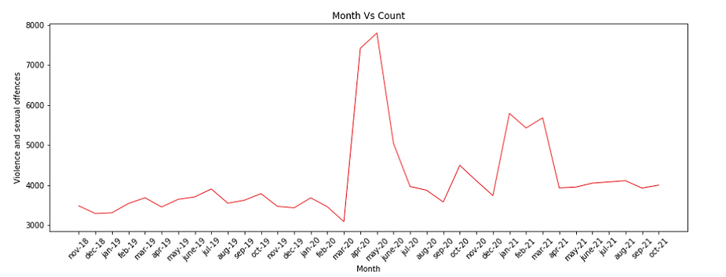

**Fig 1: Monthwise Violence and sexual Offences**

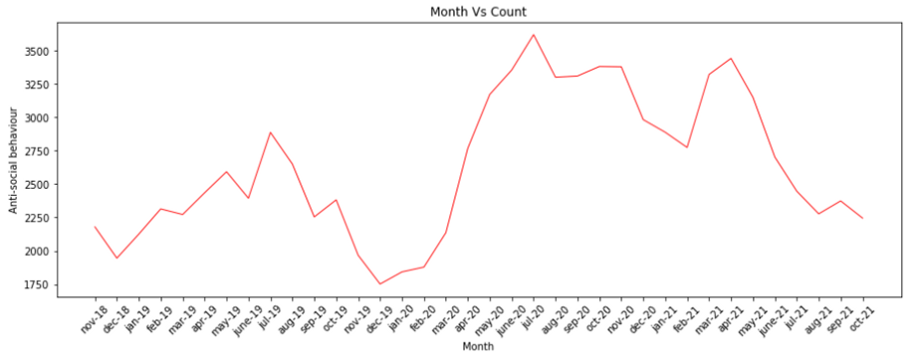

**Fig 2: Monthwise anti social behaviour**

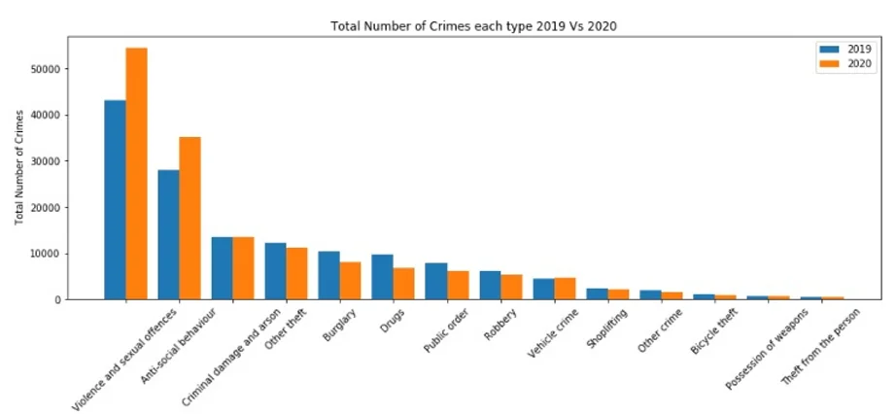

**Fig 3: Total Number of crime of each type**

**Contribution:**

Most of the existing crime data visualization projects, such as the Koreatown Crime Data Project and the UK Crime Data Analysis Project, have been useful in analyzing crime patterns. However, most of them lack either interactivity for stakeholders to explore data dynamically, scalability for handling large datasets, or the integration of diverse visualization techniques that provide a comprehensive view. This seriously limits their effectiveness in uncovering actionable insights for policymakers, law enforcement, and the public.

Motivated by these limitations, our project enhances crime data analysis by integrating multiple interactive visualization techniques to offer new, in-depth insights. Bar charts ease the comparison of crime types and area rankings, which will definitely aid categorical analysis necessary to find out high-risk crime categories. Line charts show temporal trends at a weekly and monthly scale, helping stakeholders understand how the pattern of crimes changes with time. Cluster maps provide granular details by pinpointing incidents geographically, thus enabling better spatial analysis. To address performance bottlenecks, we employ stratified sampling so that the visualizations remain responsive even if the dataset is large. Lastly, pie charts effectively represent victim demographics by age and gender to provide insight into vulnerable populations.

Importantly, every visualization in our project is interactive; therefore, stakeholders can explore data dynamically by filtering, zooming, and adjusting parameters in real time. The following interactivity allows users to further explore in depth certain aspects of the data, providing an ability to discern peak periods for crimes, patterns in demographic distributions, and locate the perfect intervention areas: where criminal activities are the highest. Given the shortcomings in existing tools, this project fills in the gaps by connecting raw crime data with actionable strategies toward improved safety in cities.

#### **Objectives**

The main objectives of the project are:

1. To analyze and visualize LAPD crime data to assess trends, hotspots, and demographic patterns.
2. To build an interactive dashboard that allows users to explore data via various filters for crime type, victim demographics, and geographical locations;
3. To generate valuable insights for police and policymakers in making resource allocation and crime prevention decisions.

We expected to find distinct markers of spatiotemporal patterns, such as concentrations of crime near densely populated areas, seasonal variation in crime rates, and demographic disparities among crimes' victims. The analysis neatly validated many of these expectations and provided insights that could greatly help public safety initiatives.

### **Process**

#### **Data Collection and Analysis**

For our project, we downloaded more than 900,000 incidents of crime data that were derived from the Los Angeles Police Department's (LAPD) open data platform[5]. To add to this data and ensure our analysis used the most recent information, we made use of their API to extract updated crime data, as the dataset is updated every two months. This included a plug-in to the live database and enabled us to automate data retrieval, that would be available for use later on. Variables in the raw data include detailed parameters, including date and time of incidents, geographical data (latitude and longitude), descriptions of crimes, demographics of victims, and status of the crime.

#### **Data Cleaning**

* Missing values in main columns such as crm_cd_desc, vict_sex, and area_name were introduced with "Unknown" for the purpose of retaining the data integrity and consistency.
* Any erroneous location entries where latitude and longitude were represented as (0,0) were identified and deleted so as not to skew geographic visualizations.
* Standardization of the date_occ column was done to datetime format to allow for both temporal analyses and visualizations. Data cleaning helped ensure that the dataset was analysis-ready and reliable for drawing meaningful insights.

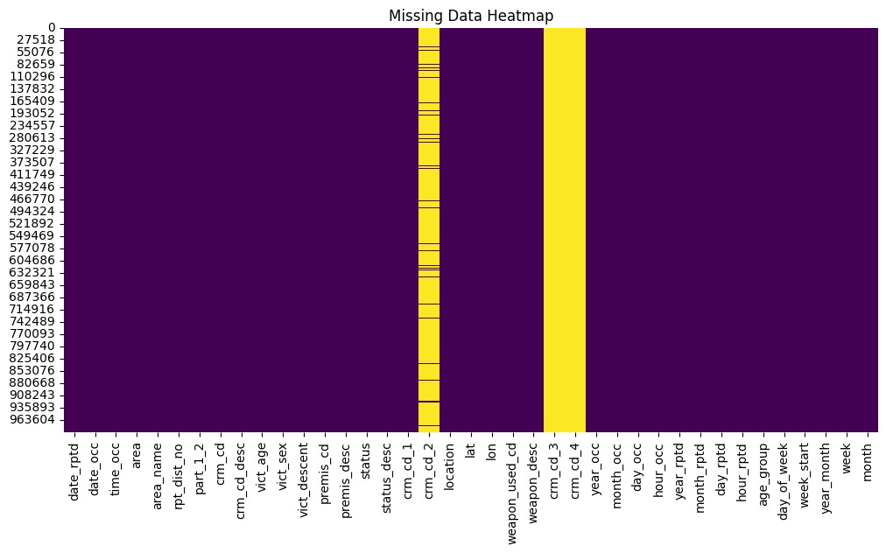

**Fig 4: Heatmap of missing data**

#### 

#### 

#### 

#### **Data Categorization**

The dataset was crunched in such a way as to make it simpler and more crystal clear for interpretation: the Violent Crimes category, Property Crimes, Cyber/White-Collar Crimes, Miscellaneous Crimes. This was done through a simple mapping function helping to conglomerate unmanageable and convoluted 100-plus specific crime codes into simple and meaningful groups. This also made it easier to visualize numbers for an audience comprised of people with varied backgrounds.

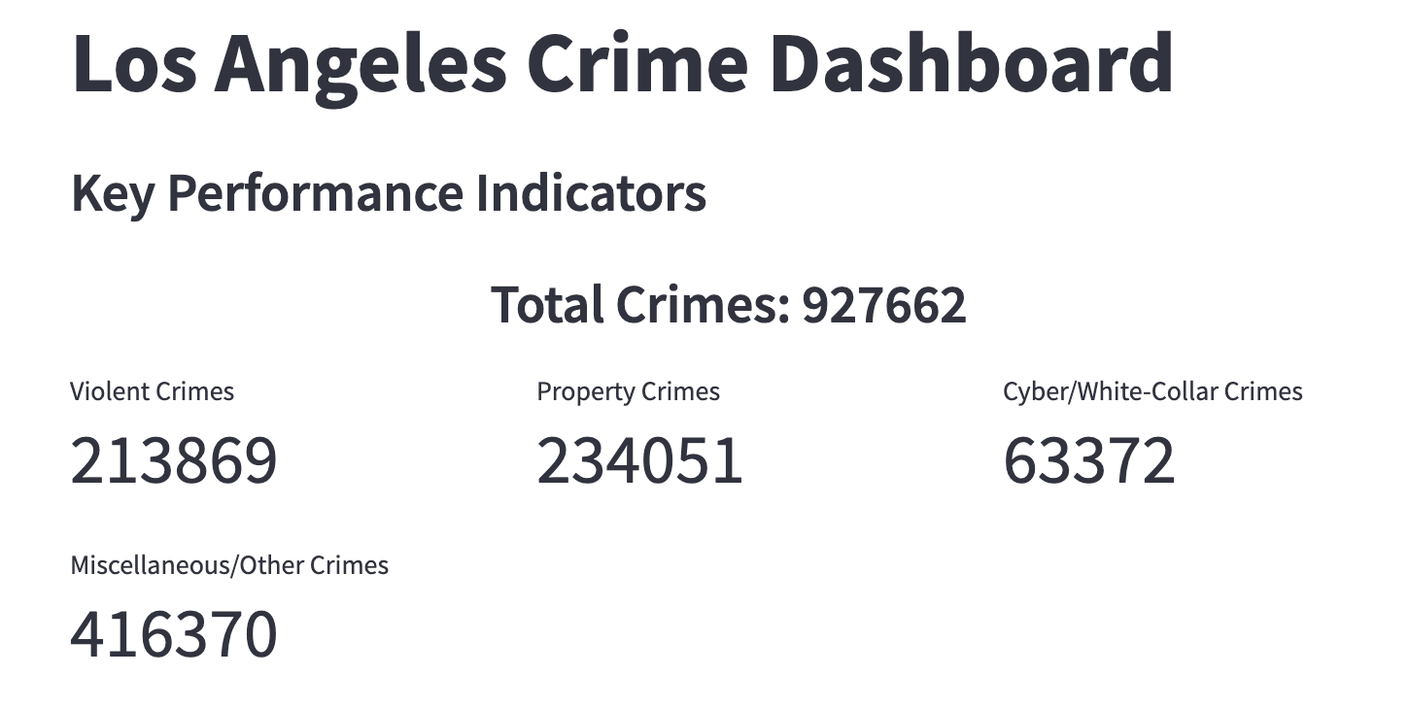

**Fig 5: Los Angeles Crime Dashboard**

#### **Challenges and Solutions**

The challenge was the size of the dataset, with more than 900,000 rows so that there was immense performance bottlenecking that occurred, especially with Clustered Maps rendering. We resorted to sampling techniques like stratified random sampling to limit our dataset to 100,000 rows but proportional across crime categories for plotting clustered map. This optimization protected the integrity of the dataset and shortened the render time while still allowing for accurate visualizations.

Another challenge was uploading the dashboard to the Streamlit community. We could not upload the big dataset since the platform is memory-constrained. We resolved this by uploading the cleaned dataset to Google Drive and pulling it through during deployment. This worked perfectly well in local testing; it was a lot harder in remote deployment, which we are still facing.

#### **Candidate Visualization Methods**

To conclude, several visualization methods were examined to acquire an insight into the crime data:

* **Heatmaps:** were used to show the density of crimes geographically, underpinning high-crime areas. This visualization is interactively zoomable on specific regions and filters by crime type and time period, making it a powerful tool for spatial analysis.
  + **Pros**: Effective at showing geographic density of crime; hotspots are easy to notice. Interactive, zooms, and can filter on type of crime and time.
  + **Cons**: There are performance issues with big datasets. Optimization by sampling was necessary to improve rendering times.
  + **Suitability**: Best applied in the spatial analysis of crime hotspots because it intuitively visualizes density.
* **Bar Charts:** Crime count rankings and a comparison of crime types were visualized by area using a bar chart. This has the simplicity required for analysis by category, and by its interactive nature, sorting or filtering data is done on the fly based on what is being asked.
  + **Pros**: Simple and intuitive to understand for categorical data. Perfect for ranking areas based on crime counts or comparing across different crime types. Very interactive in sorting and filtering.
  + **Cons**: Limited to categorical insights, not for temporal or spatial patterns.
  + **Suitability**: Excellent to perform categorical comparisons and summary statistics, hence reliable in demographic and area-specific analysis.
* **Line Charts:** showed the temporal trends on a weekly and monthly scale, reflecting how crime patterns change over time. Users can select specific time ranges or crime categories to explore trends interactively, aiding temporal analysis.
  + **Pros**: Excellent for visualizing trend over time, like time changes per week or month. Interactive and enables zooming into details over specific time ranges or according to categories.
  + **Cons**: Not suitable for spatial data or dense categorical datasets.
  + **Suitability**: Very good for temporal analyses, which can help to show trends and patterns over time.
* **Cluster Maps:** showed the individual incidents of crimes on a geographic map. Though there were performance challenges with large datasets, stratified sampling allowed us to preserve meaningful spatial patterns. Interactivity features included zooming and clicking on clusters to view detailed crime data for specific areas.
  + **Pros**: Displays individual crime incidents geographically, providing granular insights. Interactivity allows zooming and exploration of detailed data.
  + **Cons**: Computationally expensive with large datasets. Stratified sampling was required to balance performance and accuracy.
  + **Suitability**: Very effective for detailed spatial analysis to identify localized crime clusters.
* **Pie Charts:** showed the demographic distribution of victims according to their age and gender, effectively displaying the distribution of proportions. It allows interaction within the chart to filter related data, such as exploring specific demographic groups across crime types or locations.
  + **Pros**: Simple, neat, and really effective for portraying proportional data, such as demographic distributions. Interactive functionality enables drilling into specific groups.
  + **Cons**: Limited to a summary of proportions, and lacks the depth for other analyses, such as temporal or spatial.
  + **Suitability**: Best for high-level demographic overviews and fast insights into the distribution of victims.

#### **Why Certain Methods Worked While Others Did Not**

Heatmaps and cluster maps were crucial for providing spatial insights but required significant optimization to handle the large dataset effectively. For cluster maps specifically, due to the dataset's size, we had to take a sample size of around 100K data points to ensure they functioned properly. This sampling approach allowed us to maintain performance while still capturing meaningful patterns in the data. On the other hand, simpler visualizations like pie and bar charts worked seamlessly for categorical and demographic analysis as they were less computationally intensive. The stratified sampling method further enabled bulk datasets to be rendered efficiently without compromising accuracy or performance.

* Spatial analysis is emphasized through heatmaps and cluster maps, although computational intensity required optimization.
* Pie and bar charts are computationally light and useful in the case of categorical data but cannot be applied to temporal or spatial patterns.
* Line charts are considered the superior choice for temporal analysis, but they do not give any information about spatial patterns.

By fusing advanced data cleaning, categorization, and all the visualization, and at the same time making the content highly interactive, this work connects raw data of crime incidents with insight generation. The introduction of filters and dynamic elements is sure to let stakeholders explore this in a friendly manner for decision-making, be it on policy changes in crime prevention or resource distribution.

### **Results and Insights**

The analysis of LAPD crime data paints a lucid picture of crime dynamics of Los Angeles. Through the application of interactive visualizations, we distilled important information that can guide policymakers, law enforcement, and communities in their quest to mitigate crime. Here are comprehensive findings summarized:

#### **Geographic Patterns and Hotspots**

Downtown Los Angeles and adjacent neighborhoods, such as Central, Pacific, and Southwest, are consistently revealed as hotspots for criminal activity. The heatmap and clustered map show the spatial intensity of these incidents in various densely populated and commercially active areas.

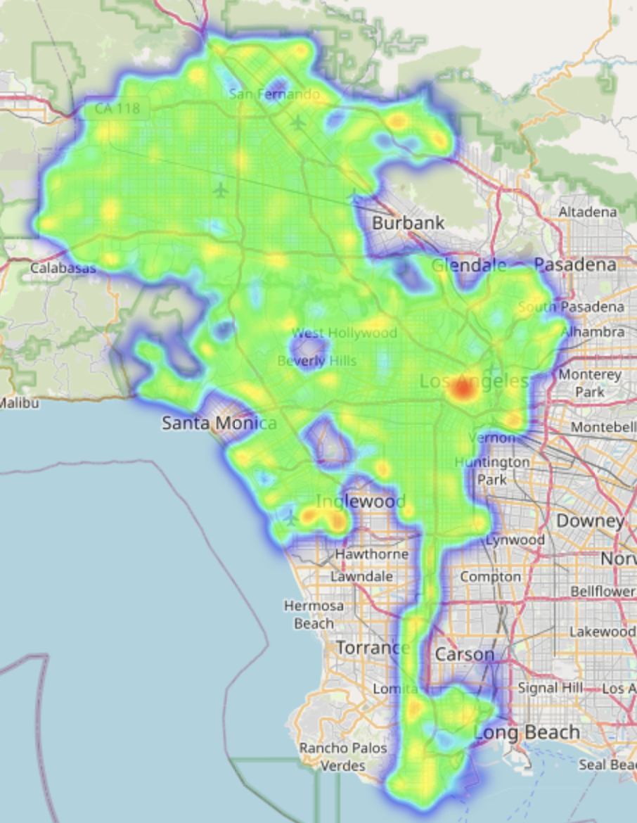

**Fig 6: Los Angeles Crime Hotspot Analysis**

Concentration of criminal activities in specific urban zones indicates a direct correlation between urban density, economic activity, and crime rate levels. This finding reflects the importance to ramp up surveillance and police work in high-density areas. Strategic urban design could incorporate improved lighting, better public spaces, and community patrol programs to significantly reduce crime in these hotspots. Due to the stratified sampling through which the clustered maps were made, the main pattern did indeed get captured, proving that this is one of the best methods for dealing with big data.

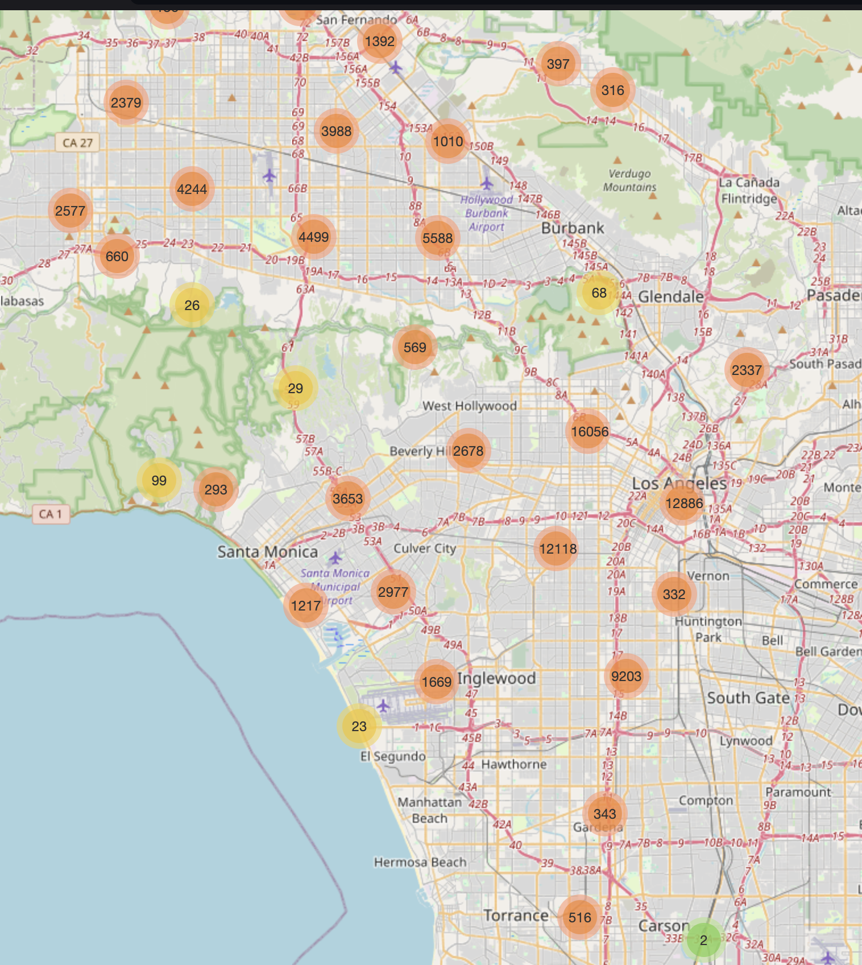

**Fig 7: Clustered crime location analysis**

#### 

#### 

#### **Temporal Insights**

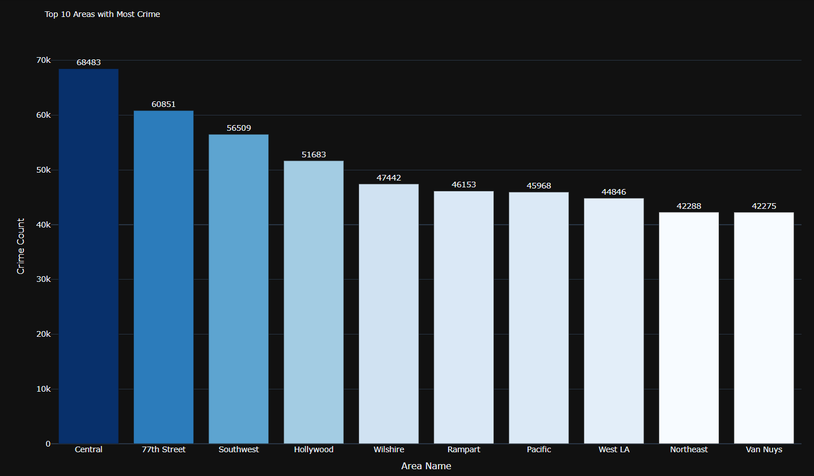

**Fig 8: Top 10 Areas with most Crimes**

**Insights from the above Visualization:-** The 77th Street, Southwest, and Central areas have long been known for their socio-economic problems. Higher rates of poverty, unemployment, and a dense population contribute to more criminal activities in these areas. The gang-related problems and scarcity of quality education or other resources add to the problem. Some of these areas have a history of systemic inequality and underfunded public services, which exacerbate the inability to maintain safety.

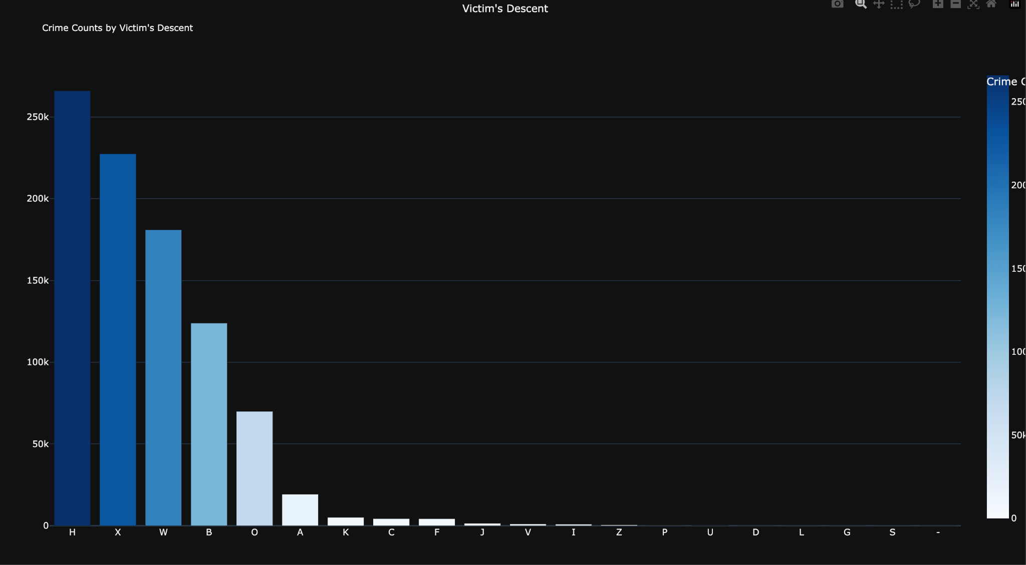

**Fig 9: Crime Analysis by Victim’s Descent**

**Insights from the above Visualization:-** Hispanic/Latin/Mexican (H) is the highest with about 250,000 cases. Cases of unknown victim descent come in second, while White victims are third, and Black victims are fourth. The cases of Z (Asian Indian), P (Pacific Islander), U (Hawaiian) and D (Cambodian) are pretty low.

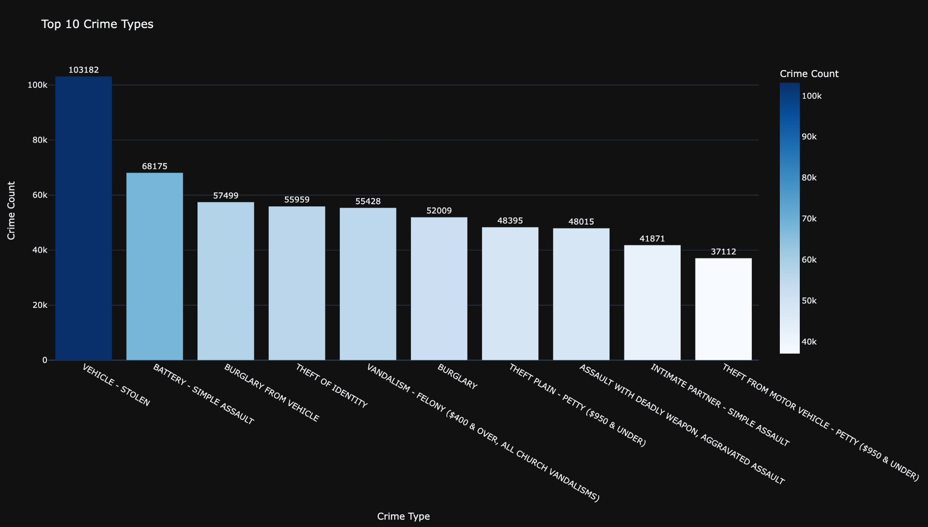

**Fig 10: Top 10 Crime Types**

**Insights from the above Visualization:-** Vehicle theft is most frequent, followed by burglary and robbery. This could be because vehicles are easy to target, especially in public areas or even at residences with minimal parking security. Crimes such as burglary and robbery usually occur in an area comprising both residential and commercial buildings, where valuables may become accessible. Substance abuse and organized criminal activities also contribute to these social problems.

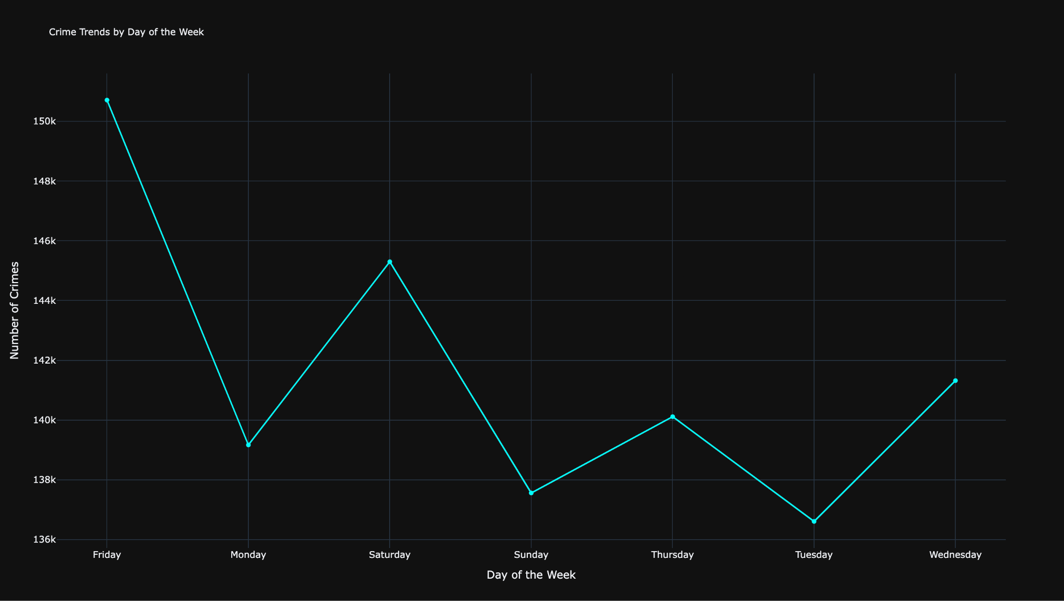

**Fig 11: Crime Trends by Day of the Week**

**Insights from the above Visualization:-** This graph peaks on Friday, reaching a count of about 142,000 crimes. The probable reason could be that increased social gatherings and nightlife on Fridays may have contributed to more public disturbances, assaults, and alcohol-related crimes. There is a drop in crime counts on Monday, probably because Mondays are generally quiet days, as people return to work or school after the weekend. On Saturday, higher crime counts occur compared to Sunday. This fits with the pattern of increased weekend activity. Sundays tend to decrease, perhaps due to less nightlife and fewer active opportunities for crime as people prepare for the upcoming work week.

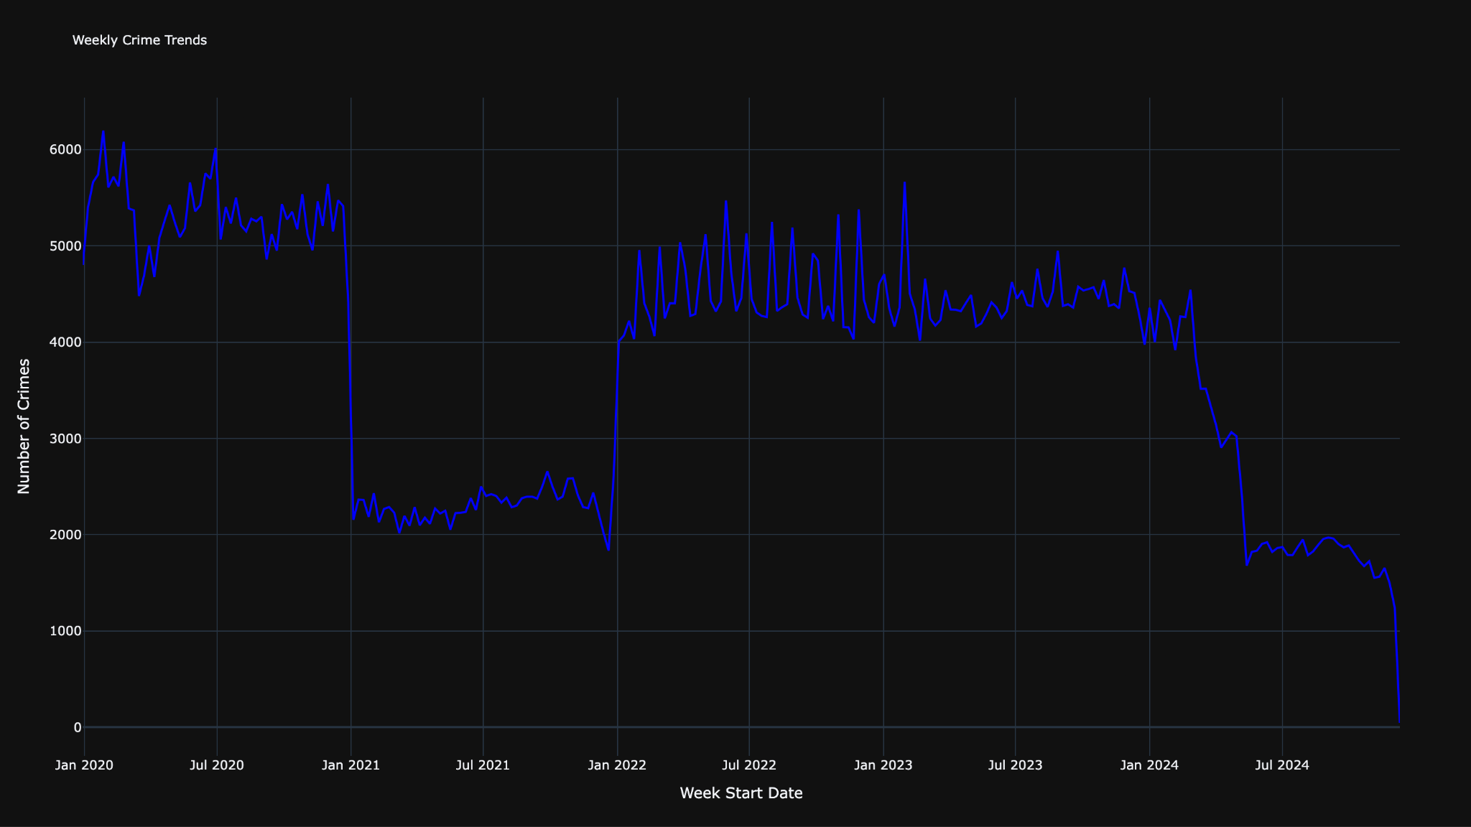

**Fig 12: Long-term weekly crime trend analysis**

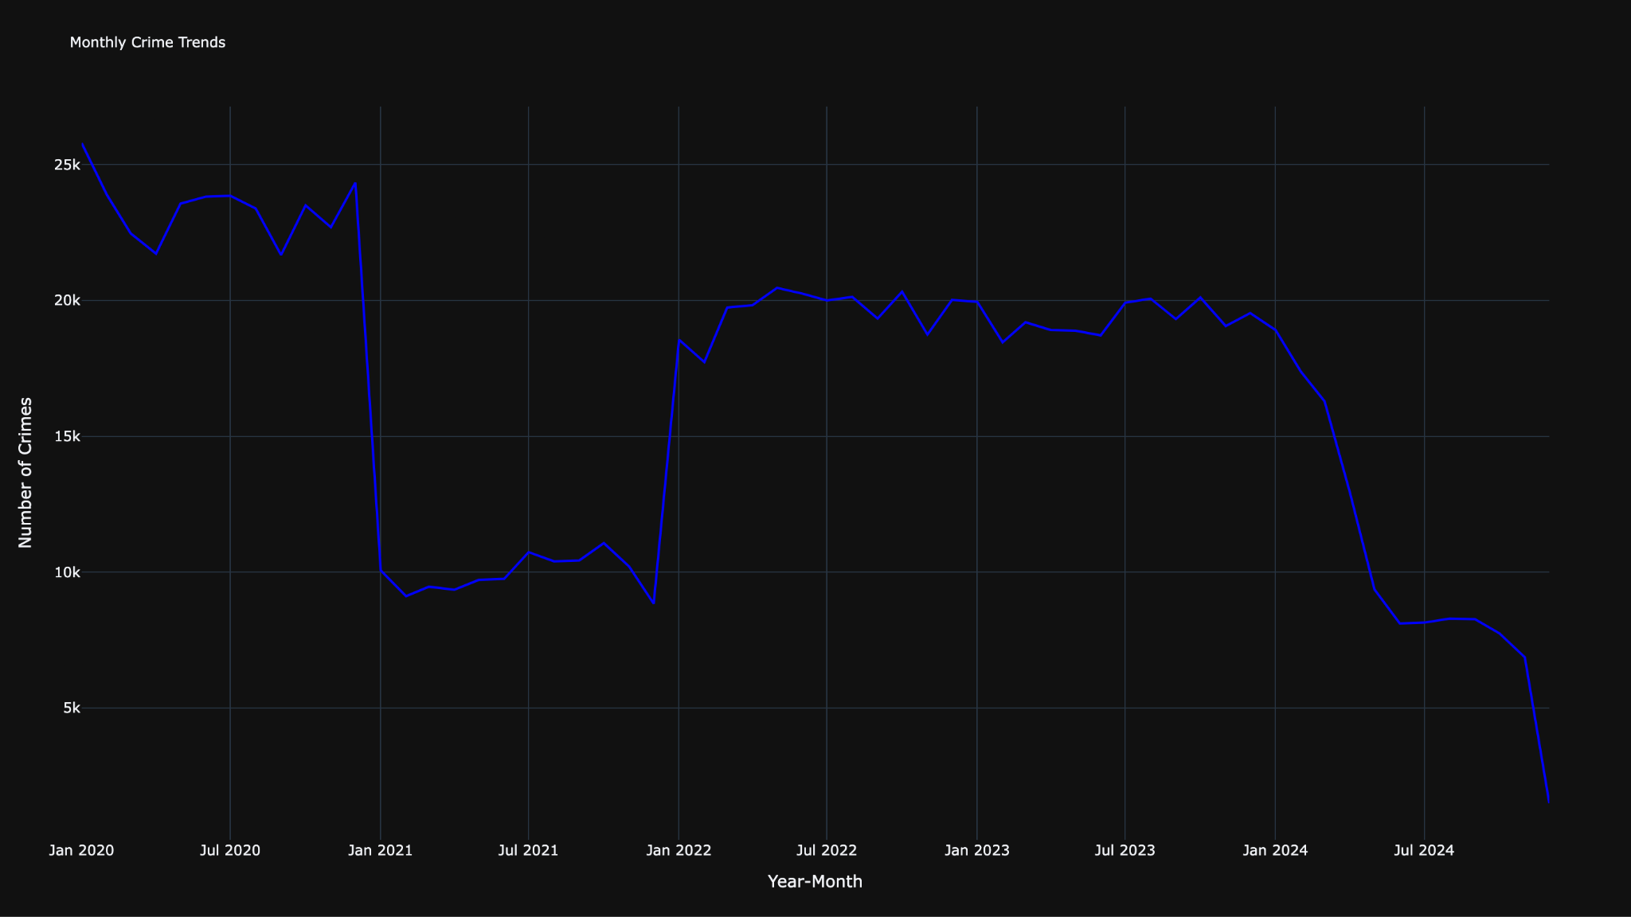

**Fig 13: Monthly crime trend analysis**

**Insights from the above 2 Visualizations:-** Early 2020: High crime rates averaging around 5,000-6,000 cases per week. Early 2021: Sharp decline to approximately 2,000-2,500 cases weekly. 2022: Significant increase back to around 4,000-5,000 weekly cases. 2023: Gradual decline trending toward 3,000-4,000 weekly cases. 2024: Continued downward trend reaching approximately 2,000 cases per week. Final period: Sharp decline to near-zero cases, likely indicating incomplete recent data.

The implementation effectively illustrates both short-term fluctuations and long-term trends in criminal activity, highlighting major shifts in crime patterns over the four-year period. The sharp rise in crime in Los Angeles between 2022 and 2023 could be due to multiple reasons. After the COVID-19 pandemic, economic problems like job losses and inflation increased stress in society, which often leads to more crimes. Changes in law enforcement policies or reduced police presence might have also played a role. Social unrest and protests during this time may have further contributed to the spike.

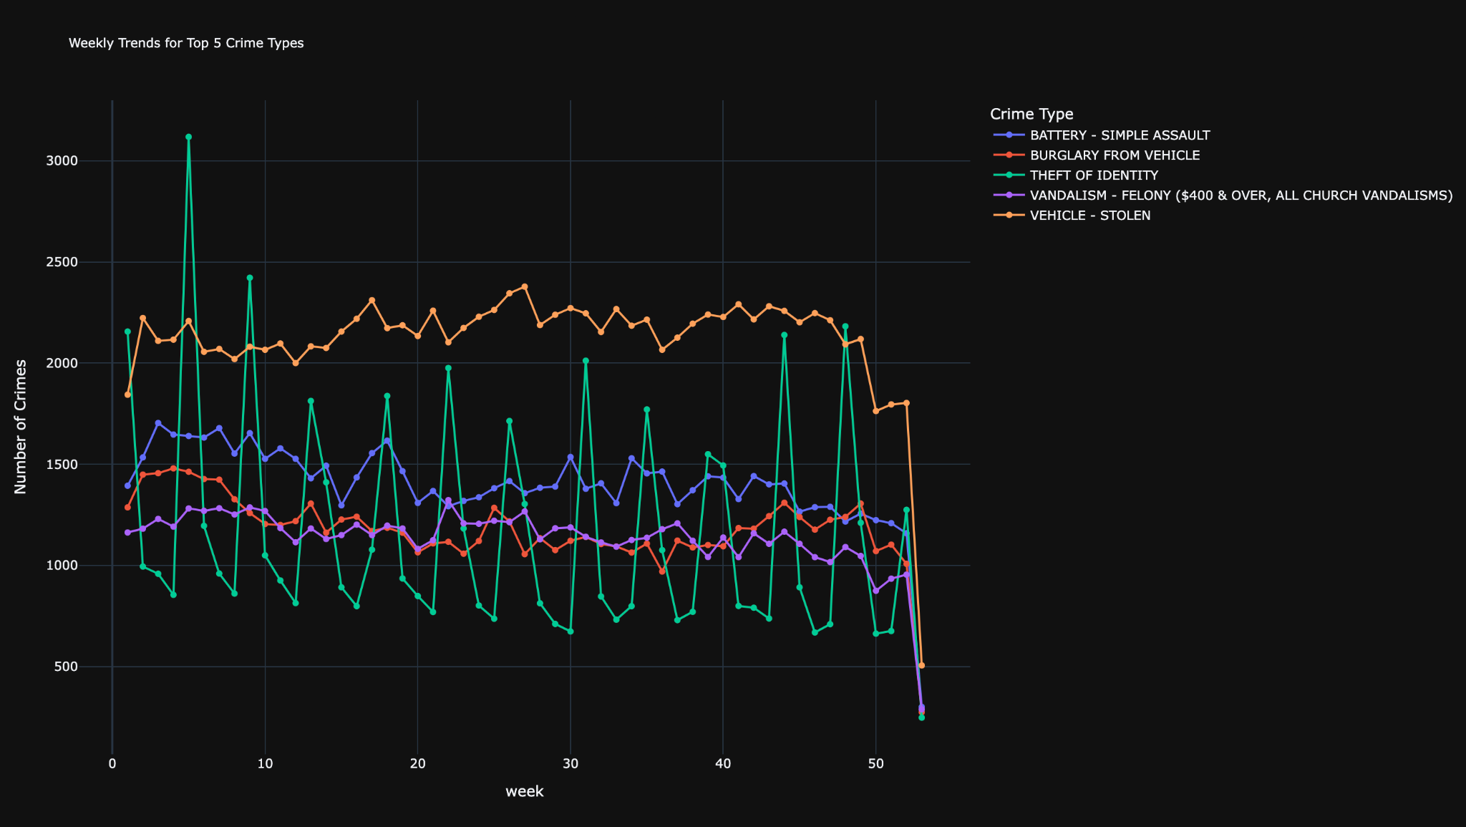

**Fig 14: Top 5 Crime Types Weekly Trend Analysis**

**Insights from the above Visualization:-** Vehicle-related crimes (Burglary from Vehicle and Vehicle Stolen) consistently show higher frequencies. Battery-Simple Assault maintains relatively stable numbers throughout the period. Theft of Identity shows the most volatile pattern with sharp spikes and drops. Vandalism-Felony maintains the lowest but most consistent numbers among the top 5. All crime types show a sharp decline in the final weeks, likely due to incomplete recent data.

The implementation effectively demonstrates both the relative frequency of different crime types and their individual temporal patterns, providing valuable insights for law enforcement resource allocation and crime prevention strategies.

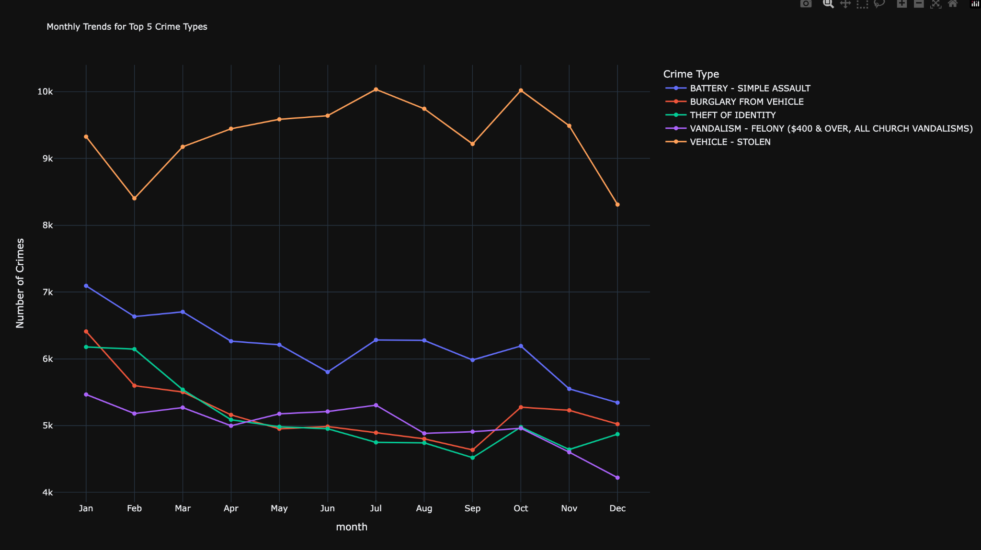

**Fig 15: Monthly Crime Type Distribution Analysis for top 5 crimes**

**Insights from the above Visualization:-** Vehicle theft shows the highest frequency, peaking in June and October at around 10,000 incidents. Battery-Simple Assault maintains consistent levels around 6,000-7,000 cases with a gradual decline through the year. Burglary from Vehicle shows moderate fluctuation between 5,000-6,000 incidents. Theft of Identity displays the most volatile pattern with sharp spikes in early months. Vandalism-Felony maintains the lowest but most stable pattern throughout the year.

Information from such trends can inform tech-based predictive policing models, deploying officers in real-time to city hot spots during any number of high-risk areas. Such approaches can prevent crime from occurring through immediate intervention.

#### **Demographic Analysis**

Analyzing victim demographics paints a compelling picture:

* **Age Groups:** The most substantial number of victims would fall in the 19-30 age bracket, simply because they are more active in urban and nightlife settings. This follows with 31-45 years of age.
* **Gender:** Slightly more males than females are victims, but the high proportion of unidentified cases demonstrates a gap in reporting practices.
* **Descent:** Victim proportions are dominated by Hispanic/Latino and White people, which reflects the city’s ethnic composition. The extraordinarily high rates of victimization by Black people pose questions of socio-economic and systemic inequalities.

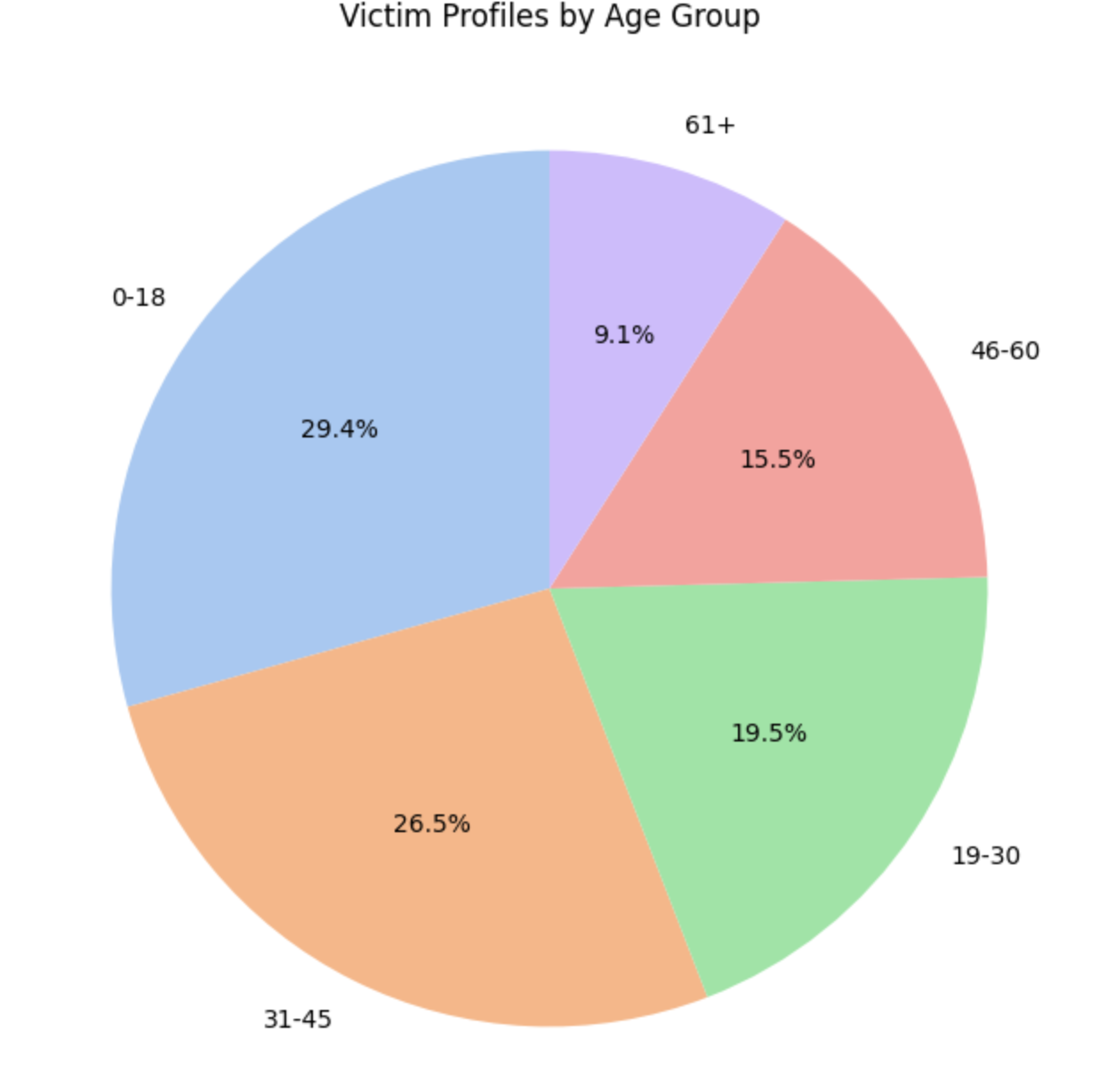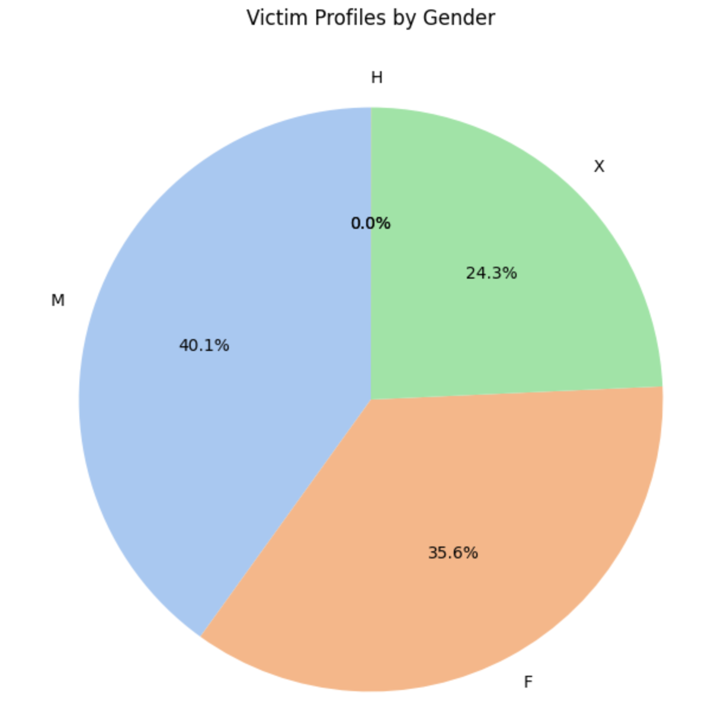

**Fig 16: Age Distribution Analysis of Crime Victims (left), Gender Distribution Analysis of Crime Victims (right)**

**Insights from the above Visualizations:-** Knowing victim profiles gives rise to tailored community safety programs. For example, youth-based outreach organizations at nightlife venues could act as a buffer against risks. Likewise, addressing systemic factors behind racial disparities in victimization could contribute toward greater social good.

#### **Crime Type Distribution**

It is also noteworthy that property crimes, particularly vehicle thefts, form the bulk of the data. Identity theft and intimate partner violence also contribute to the figures significantly. Interestingly, low-frequency crimes, such as bribery and gun-related offenses, have a localized but profound impact, with most of such crimes calling for specific interventions. With such high crime figures, certain technological interventions may be employed, for instance, anti-theft devices for vehicles; in addition, addressing intimate partner violence requires victim support and pressure for enforcement.

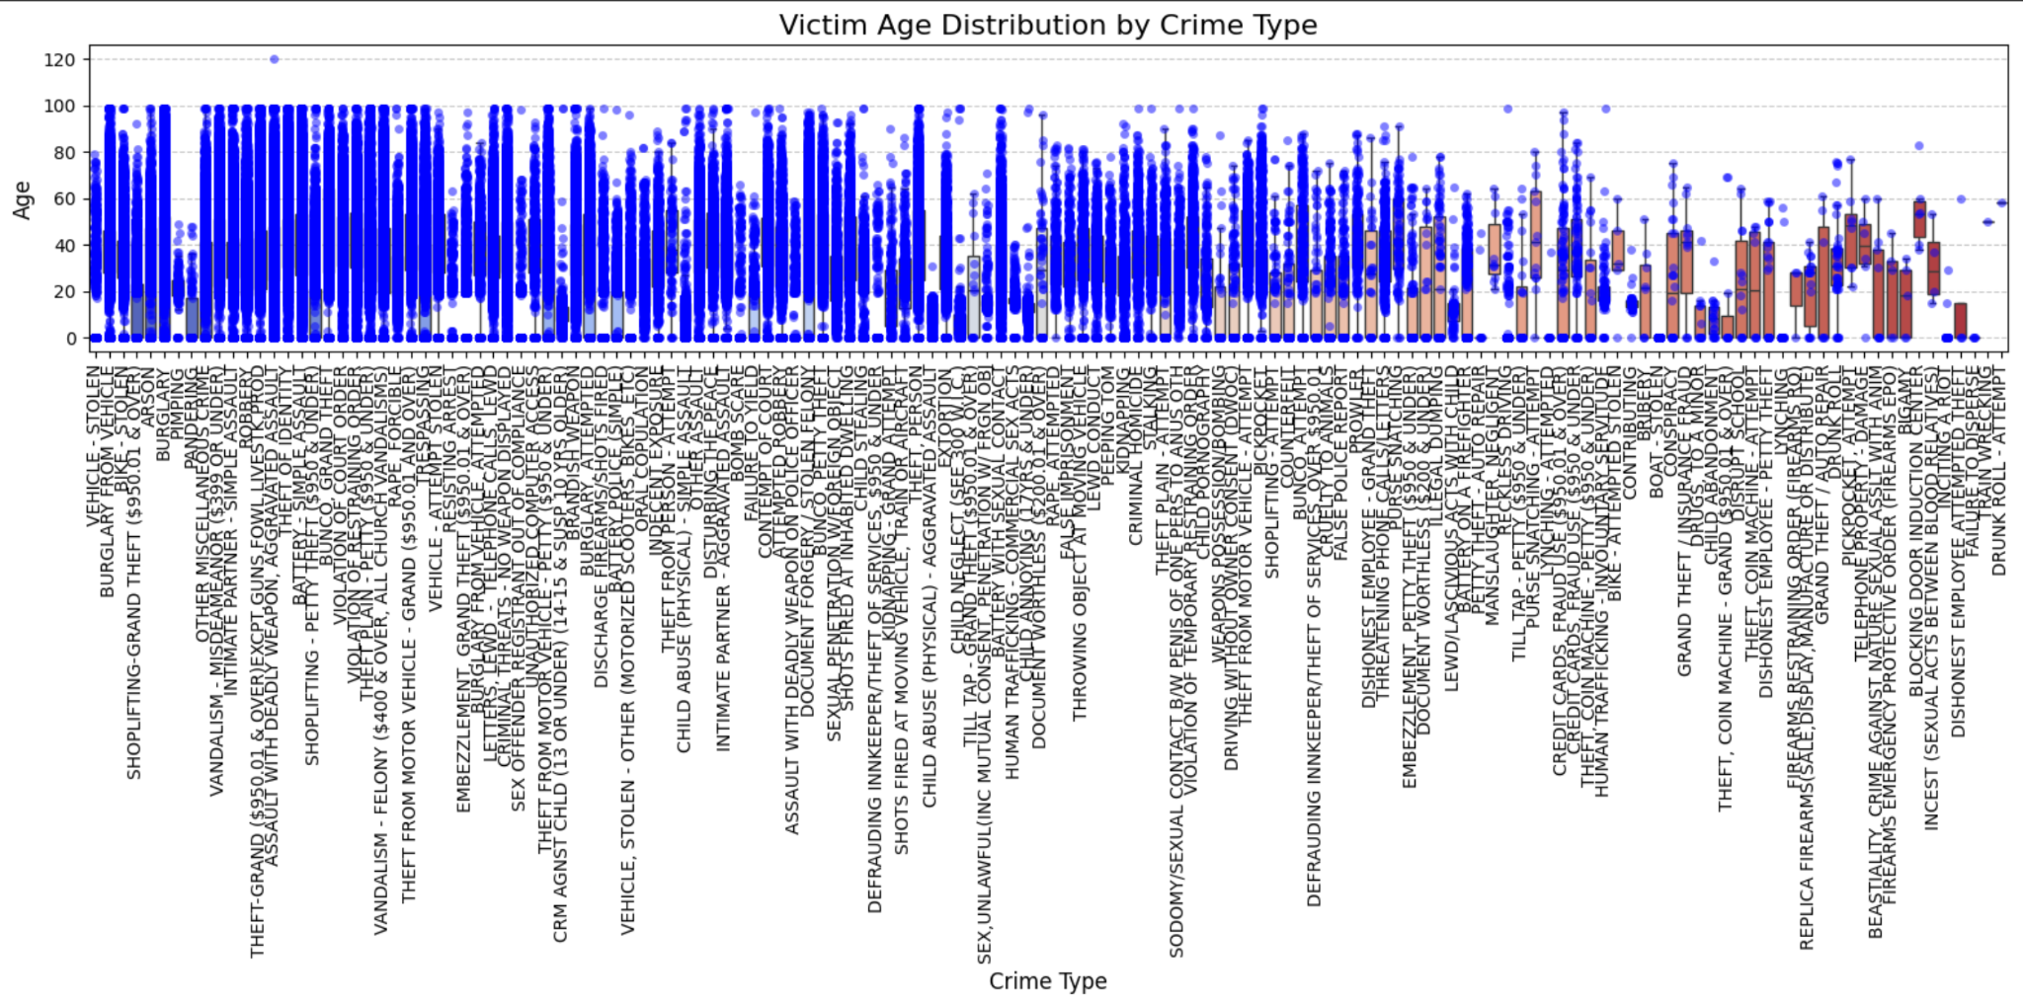

**Fig 17: Victim Age Distribution Analysis Across Crime Types**

**Insights from the above Visualization:-** Most of the crime types show higher density of victims in the 20–40 age range, which may suggest that this age group is more commonly victimized across a range of crimes. Other crimes, such as 'Child Abuse' or 'Sexual Exploitation', have a clear clustering at the lower end of the age axis, with most victims under 18. Crimes like 'Insurance Fraud' show dots clustering more toward the higher age range of 60+ years. These crimes may especially affect elderly people. For some other crimes, such as 'Theft' or 'Burglary', the victims are spread almost equally among all age groups, suggesting that these crimes can affect any age group.

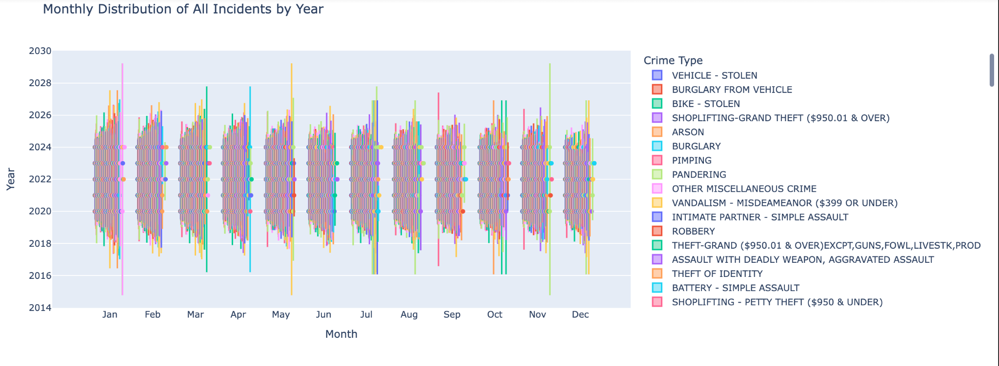

**Fig 18: Crime distribution with violin plot analysis**

**Insights from the above Visualization:-** It is to be noted that certain crimes have a tendency to reach their peak in specific months. In this case, there are quite obvious peaks for the Jan-Feb, May-June, and Nov-Dec months. This could be due to holiday debt/layoff period, increased outdoor activity, and vacations. Vehicle thefts and burglary incidents also appear to increase during summer months when people go on vacation and leave vehicles unattended. Crimes such as 'Shoplifting' have distinct peaks in many years during the months of November and December, which coincide with the holiday shopping season. Retail environments are likely more vulnerable due to increased customer traffic and distractions.

#### 

#### **Visual Craftsmanship**

Each visualization is designed to maximize interpretability and insight generation:

* **Bar Charts** clearly rank geographic and categorical data, making them ideal for comparative analysis.
* **Clustered Maps** offer a detailed spatial overview, while heatmaps highlight intensity.
* **Pie Charts** distill complex demographic distributions into digestible insights.

Effective visualization ensures stakeholders, regardless of technical expertise, can grasp and act upon the findings. The use of Plotly and Folium allowed for visually polished, interactive outputs that enhance user engagement.

Our project visualizations have been developed to be fully interactive. Stakeholders can explore data in real time by filtering, zooming, and adjusting several parameters to focus on what is really relevant. This level of interactivity allows the deepening of critical insights, like finding patterns in demographics, spotting peaks of crime periods, and establishing the optimal area for interventions where criminal activities are most concentrated.

### **Discussion, Conclusion, and Future Work**

## **Discussion**

The project provided a valuable opportunity to delve into the crime trends in Los Angeles, revealing both significant insights and challenges. The analysis identified Downtown Los Angeles as a persistent crime hotspot, which aligns with its high population density and economic activity. Temporal analysis showed peak crime occurrences on Fridays, likely due to increased social activities. These findings suggest that targeted interventions, such as increased police presence or community programs on high-risk days and areas, could effectively reduce crime rates.

The study also uncovered demographic disparities, particularly affecting teenagers and certain racial groups, raising critical questions about systemic inequalities. For instance, Hispanic and Black communities showed higher victimization rates, which could be attributed to socio-economic factors and historical inequalities. These insights emphasize the need for policies addressing these underlying issues to ensure equitable safety measures.

The project faced challenges with the large dataset size, which required innovative solutions like stratified sampling to manage computational loads effectively. This approach ensured that visualizations remained responsive without compromising data integrity. However, scalability issues persisted when attempting to deploy the dashboard on platforms like Streamlit.

The interactive nature of the dashboard allows stakeholders—policymakers, law enforcement, and community leaders—to explore data dynamically. This capability is crucial for developing informed strategies that address both immediate safety concerns and long-term systemic issues. By transforming raw data into actionable insights, the project supports evidence-based decision-making processes.

## **Conclusion**

The Los Angeles Crime Dashboard was an excellent way to contextualize urban crime patterns by transforming raw data into interactive visualizations. These visualizations allowed stakeholders to make informed decisions and develop targeted safety measures. The study affirmed how entrenched the drivers of crime rates are in urban density, social behaviors, and systemic inequalities. Such issues require coordination in efforts among law enforcement, policymakers, and community members.

By leveraging data-driven insights, the project contributes to a broader understanding of urban safety challenges. Future iterations could focus on integrating predictive analytics to anticipate crime trends and enhance scalability through cloud-based solutions for real-time analytics. Additionally, conducting comparative studies involving multiple cities could further contextualize findings and broaden their applicability.

The project overall demonstrates how data visualization might serve as a powerful trigger toward the articulation of strategies on urban safety. Building on the limitations identified and leveraging new technologies, future efforts can mark significant leaps in the resilience of urban communities toward a safer and more equitable future.

### 

### 

### **Future Work**

Building on the foundation established in this project, future iterations could address the following enhancements:

1. **Integrating Predictive Analytics:** Employing machine learning models to predict crime-prone areas and times, enabling proactive interventions based on historical trends.
2. **Enhancing Scalability:** Adopting big data platforms like Apache Spark or cloud-based solutions to process larger datasets and facilitate real-time analytics.
3. **Conducting Comparative Analysis:** Expanding the study to include multiple cities to identify both unique and shared challenges in urban safety, thereby broadening the applicability of the findings.

Data visualization has proven to be a transformative tool, not only for understanding historical trends but also for shaping future strategies for urban safety. By addressing the limitations identified in this study and leveraging emerging technologies, subsequent efforts can significantly advance the resilience of urban communities, paving the way for a safer and more equitable future.

**References**

1. SoDAVi Group. Koreatown Crime Data Project. Visualizing Open Crime Data from Los Angeles Open Data Initiative. March 14, 2016. <https://sodavi.org/portfolio-items/crime-data/>.
2. Codersarts. Crime Data Analysis and Visualization Project. Codersarts Blog. December 12, 2024.<https://www.codersarts.com/post/crime-data-analysis-and-visualization-project>.
3. Weisburd et al. (2015) Hot spots. <https://cebcp.org/evidence-based-policing/the-matrix/micro-places/micro-places-weisburd-et-al-2015-hot-spots/>
4. Cynthia Lum, Daniel S. Nagin. Reinventing American Policing: A Seven-Point Blueprint for the 21st Century. November 2016.<https://www.researchgate.net/publication/309814954_Reinventing_American_Policing_A_Seven-Point_Blueprint_for_the_21st_Century>
5. Los Angeles Police Department (LAPD) Crime Data:<https://data.lacity.org/Public-Safety/Crime-Data-from-2020-to-Present/2nrs-mtv8/about_data>